Generate Social Network Access Token

*Version 1.0*

Contents

1. Facebook 1

2. Twitter 11

3. Linkedin 16

4. Instagram 20

# Facebook

Access to the <https://developers.facebook.com/>, we need to login to create the app with access token:

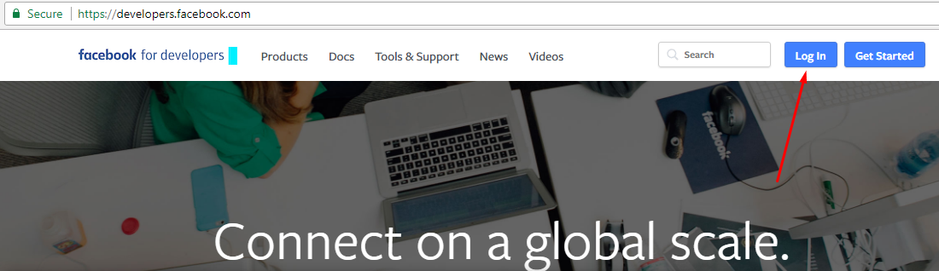

After logged in, click on the “Add a New App” button to create an app

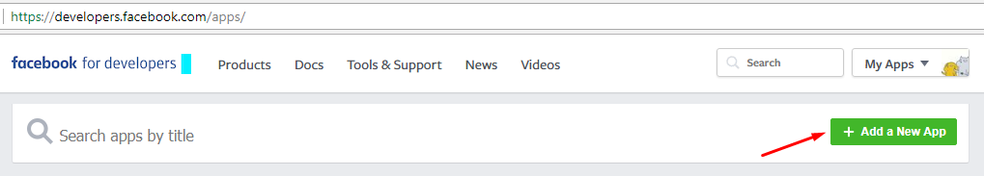

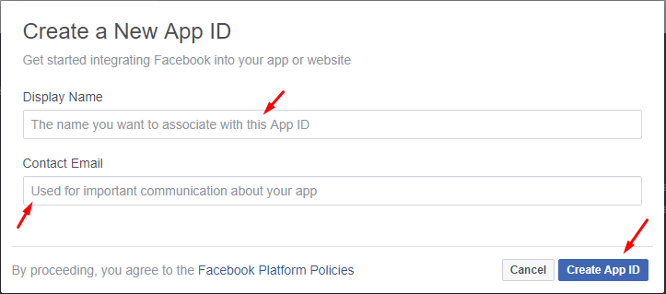

Navigate to menu Settings -> Advanced, find the Security section and change the option “Allow API Access to App Settings” to Yes then click Save Changes

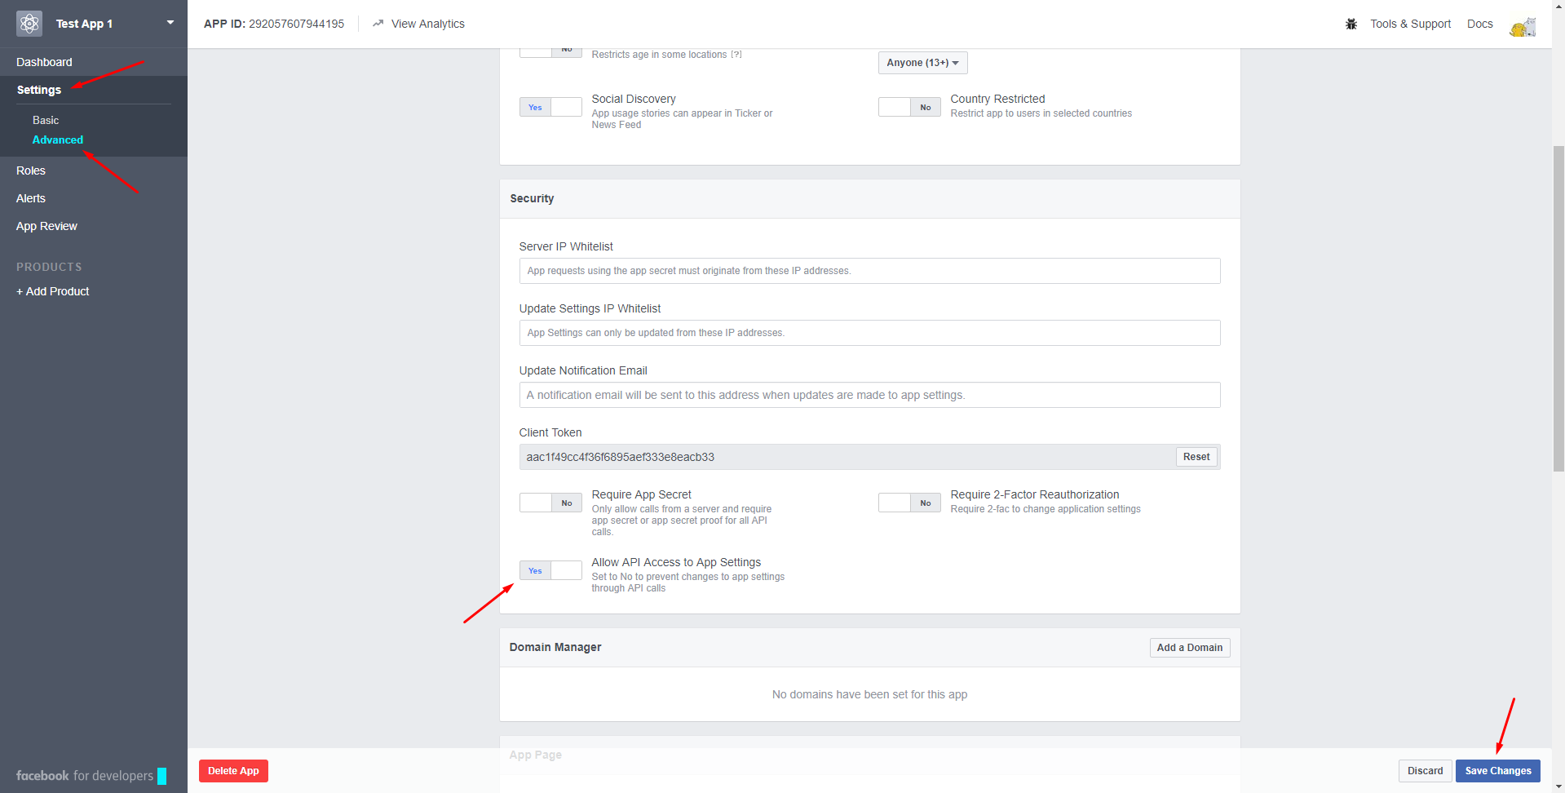

Click on the “Tools & Support” on the top right, then click on the “Access token tool” to see the access token

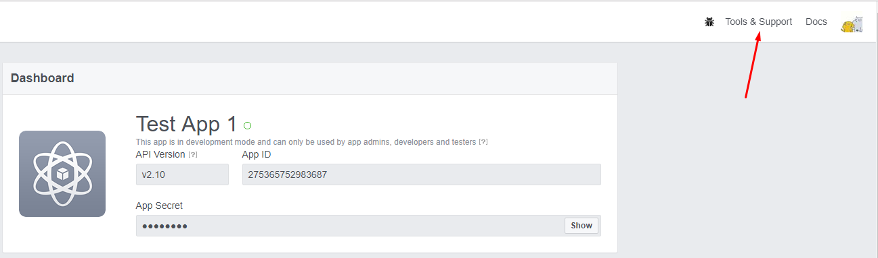

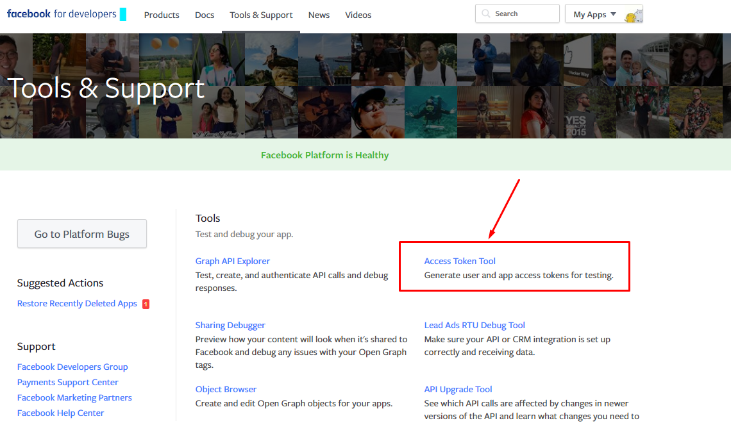

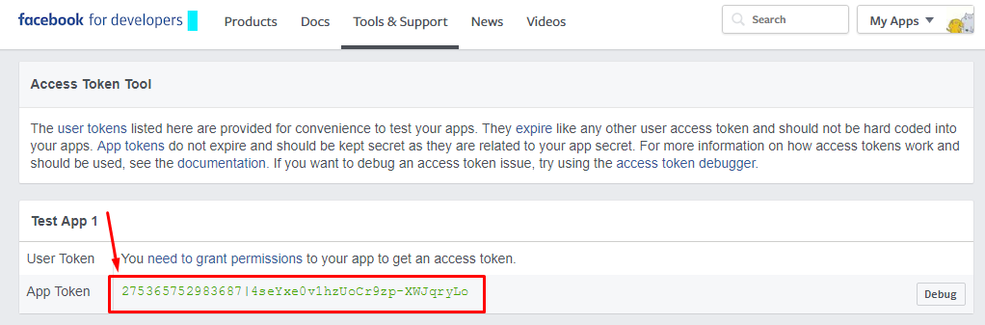

Note: After completing generation, please provide the **“App Token”** and **Page ID**

About the Page ID, please access to the facebook page, on the left middle click on the “Abou” label, sroll down and we can see the Page ID

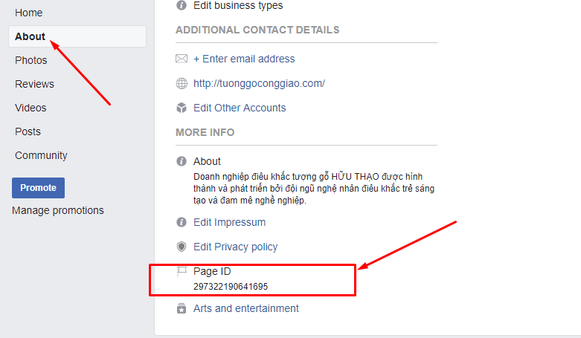

**Updates:**

We might not use the access token we genernated above because of Facebook Policy updates. We need to submit the App to facebook team to be reviewed and approved.

From the App screen, click on *App Review* on the left menu, then click on *Start a Submission*

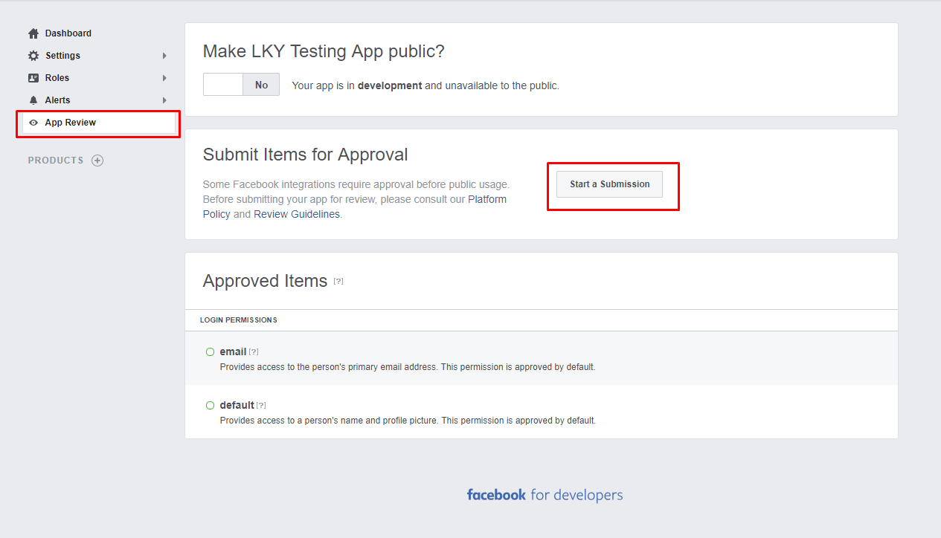

On the popup, scroll down and check on option *Page Public Content Access* then *Add*

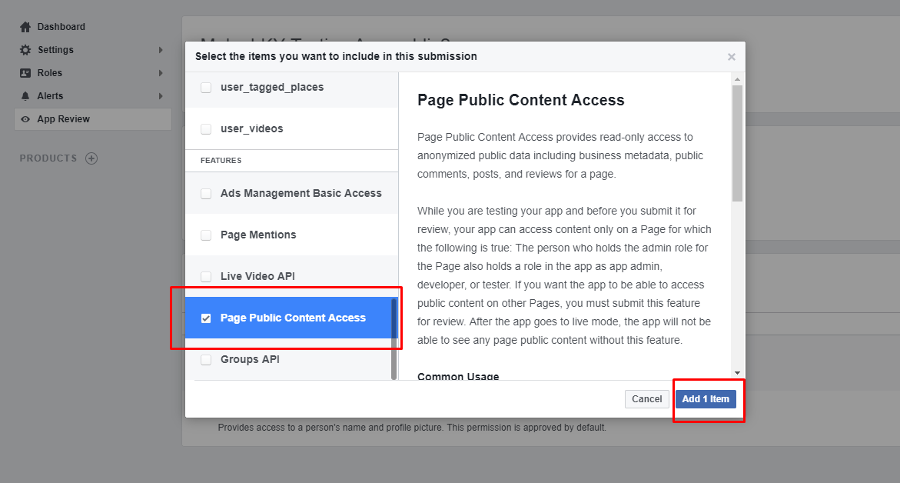

Possibly, we need to complete some tasks which facebook informs before to submit such as:

* Update the App Icon
* Add Privacy Prolicy URL
* Set Business Use
* …

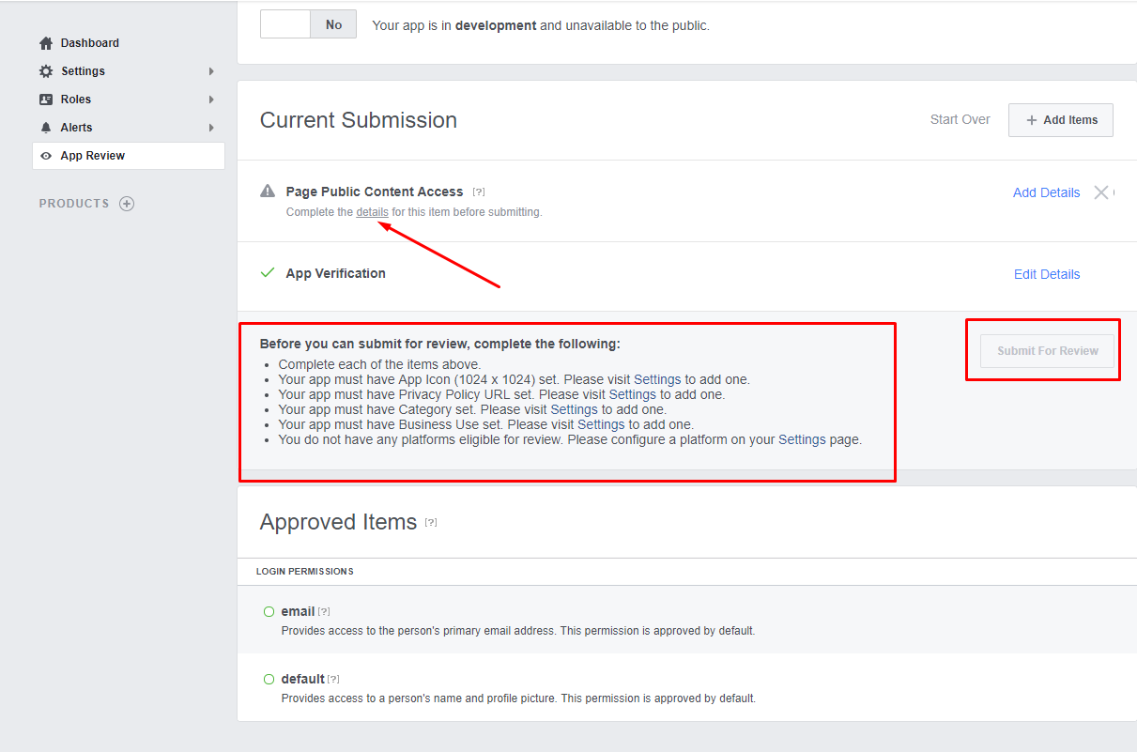

Go to Settings -> Basic and fill required information as below:

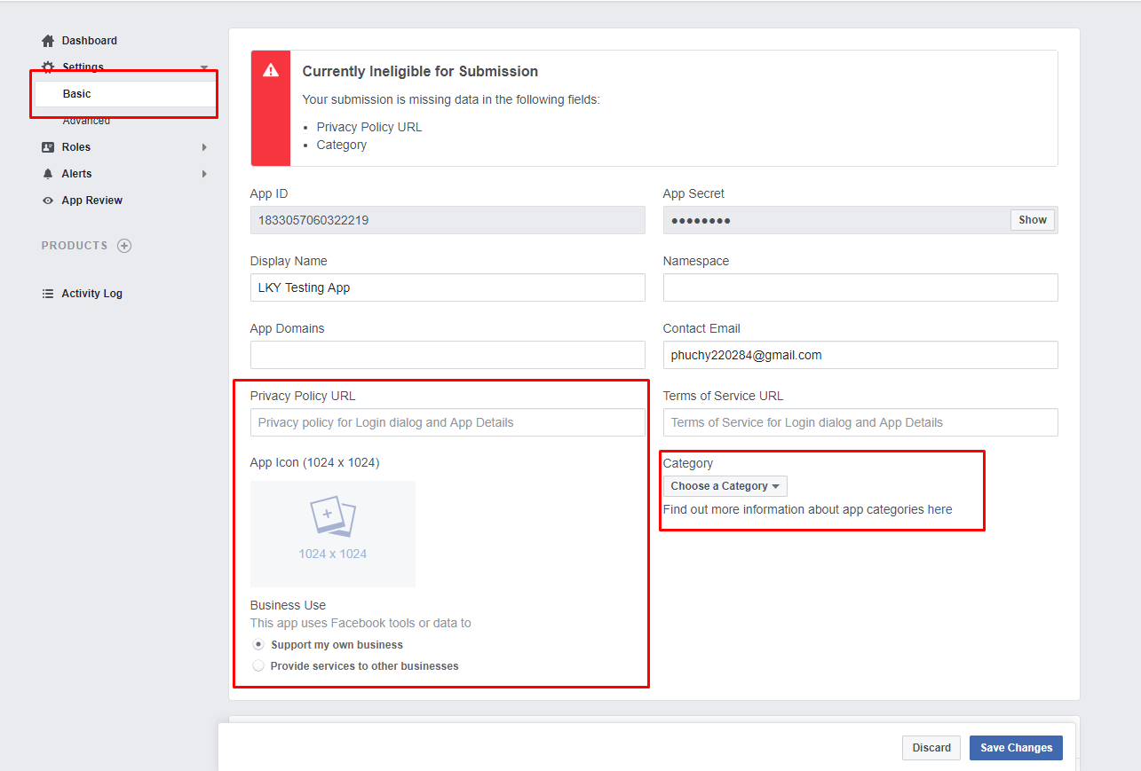

Also, we need to add a platform. Scroll down on current page and click on Add Platform button -> choose Website

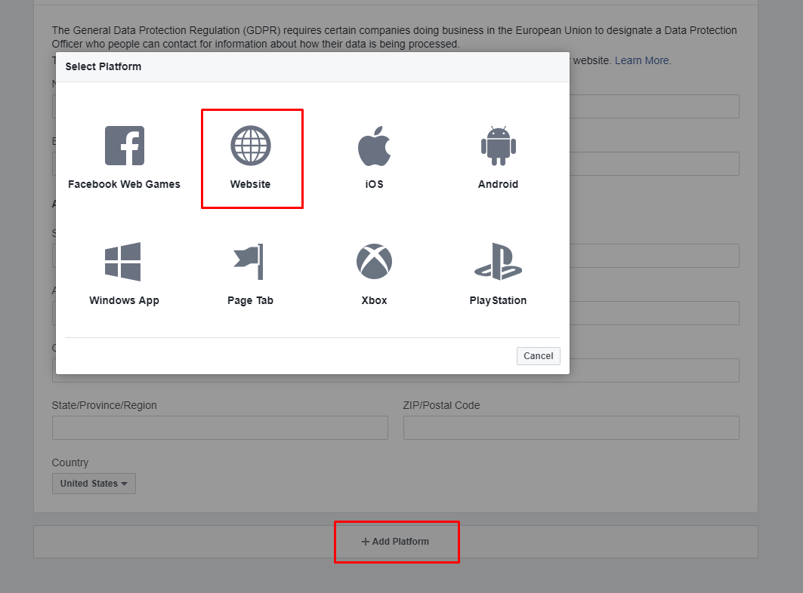

Enter your website URL and and save all changes

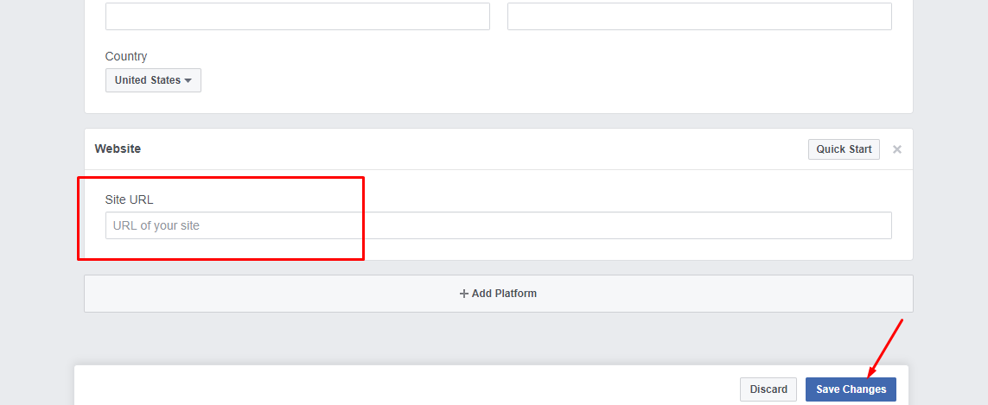

Now, we come back to App Review and can see that almost issues have been solved

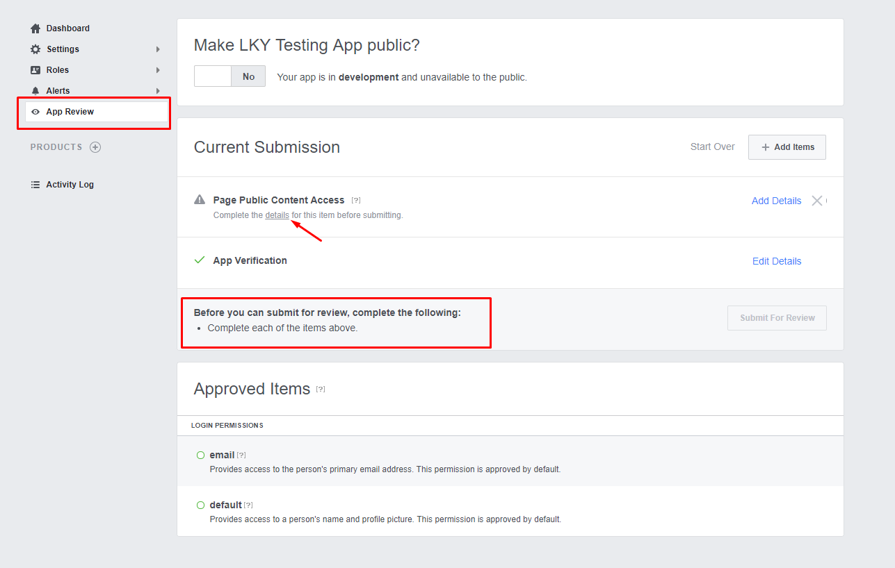

Almost there, click “details” hyperlink and we will see the popup:

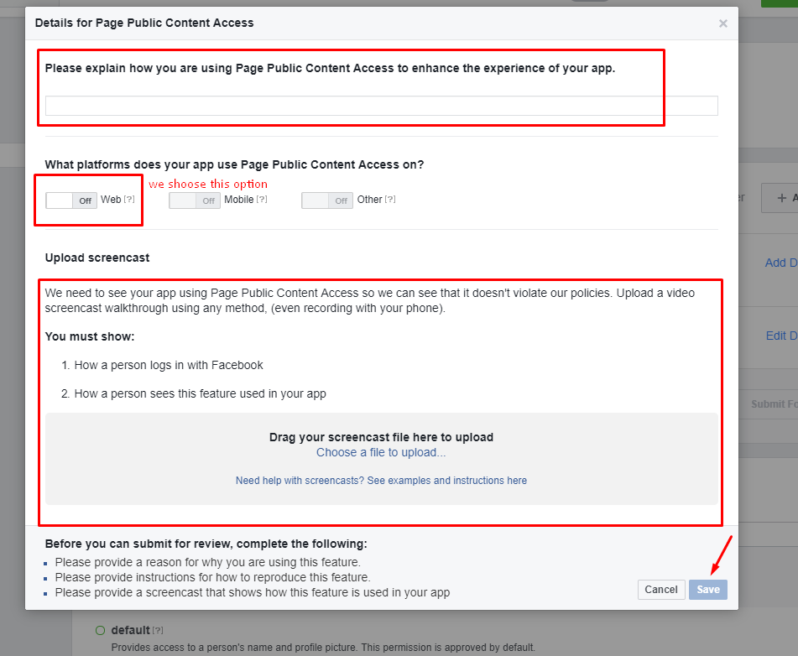

We need to input the information before clicking on Save.

After that, we can do submit for review

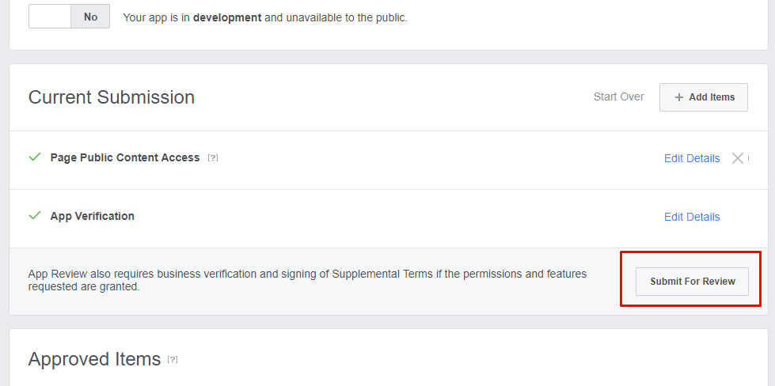

Facebook will notify us once the review is completed. We also can check the result by going to Alerts section:

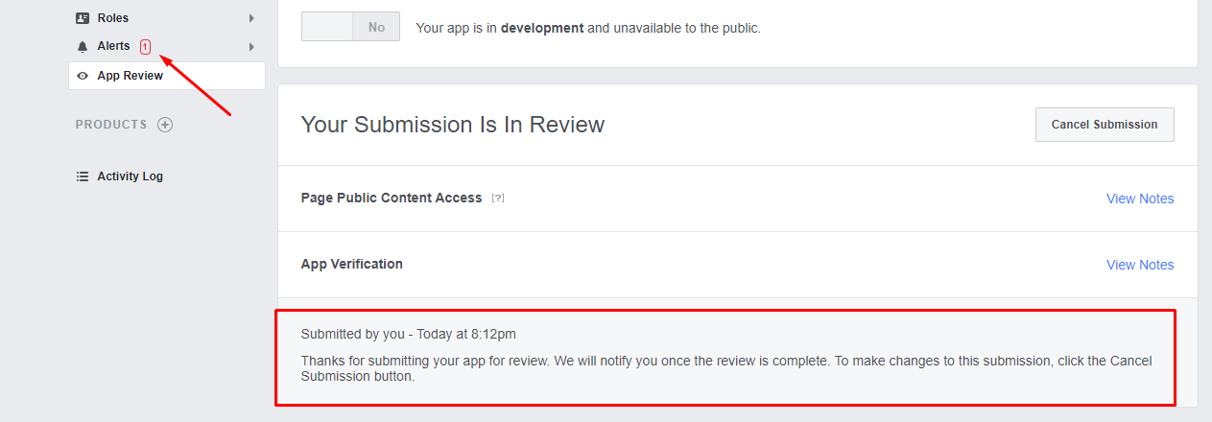

# Twitter

Access to the <https://apps.twitter.com/>, and login to the app

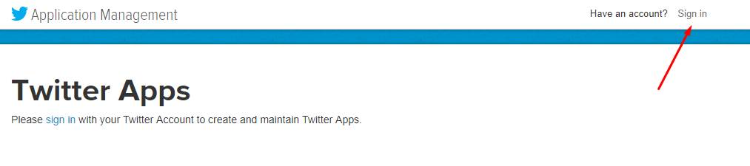

And create an app

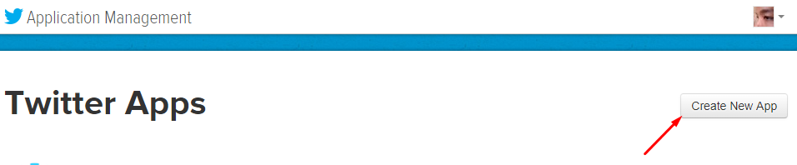

Fill the values and click on the “Create your Twitter application” button to create new app

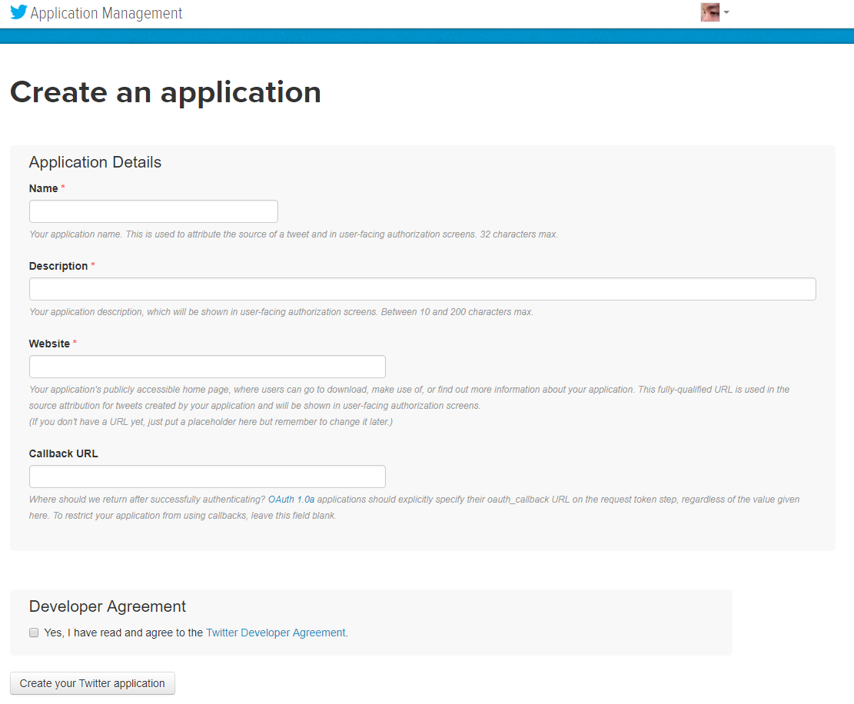

Navigate to Keys and Access Tokens tab to see the Consumer Key and Consumer Secret

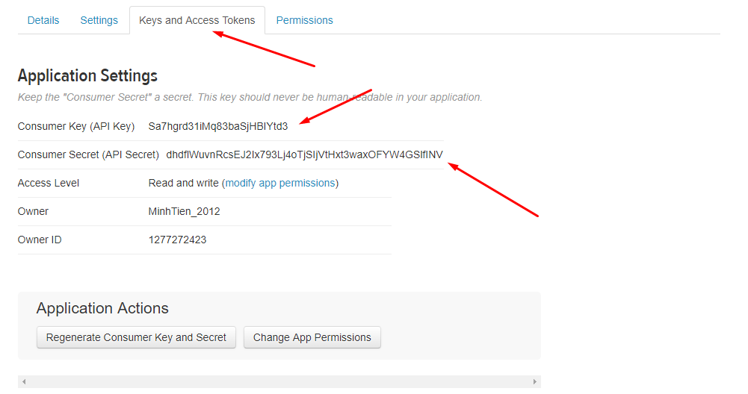

We can use the them to generate the access token or Click Create my access token near the bottom of the page to generate an authorized Access Token and Secret.

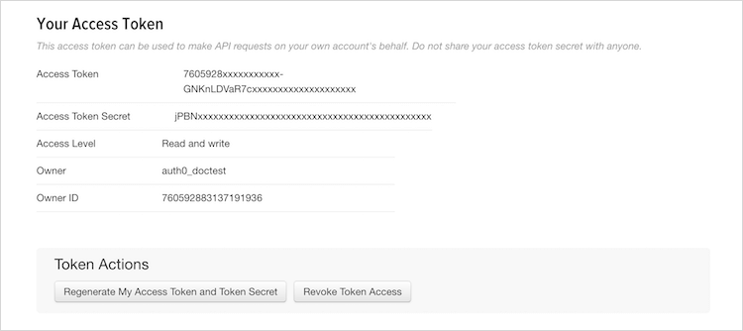

Note: Please provide the **Consumer Key** and **Consumer Secret** and **Screen Name**

About the Screen Name, please access to your twitter and see the text under the name on the left screen, below:

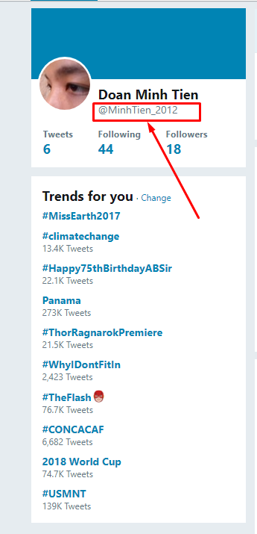

# Linkedin

Access to the <https://developer.linkedin.com/>, click on the menu “My Apps” to create new app

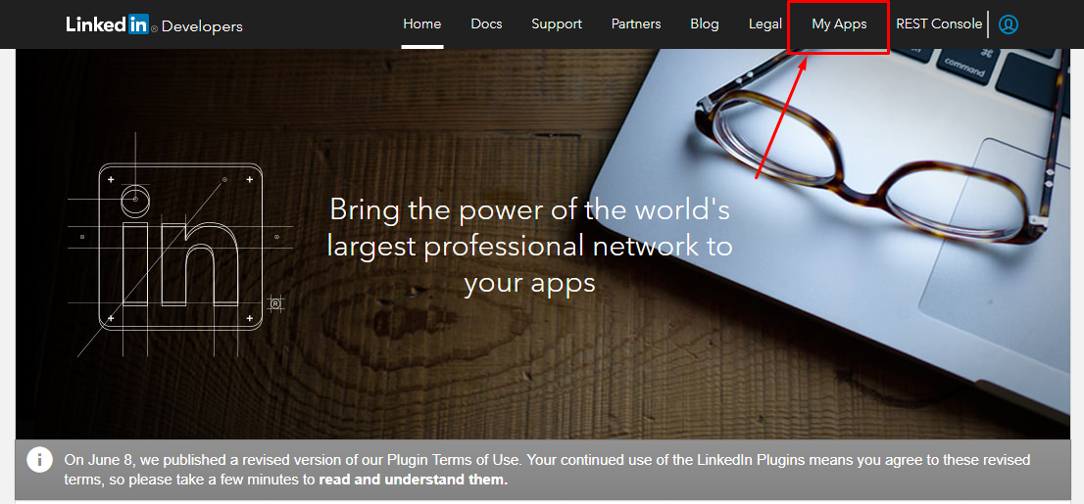

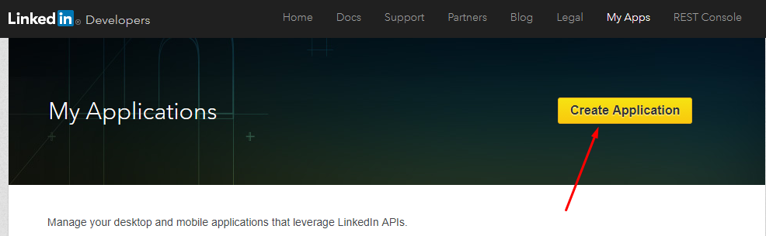

Then fill the information and click on “Submit” button

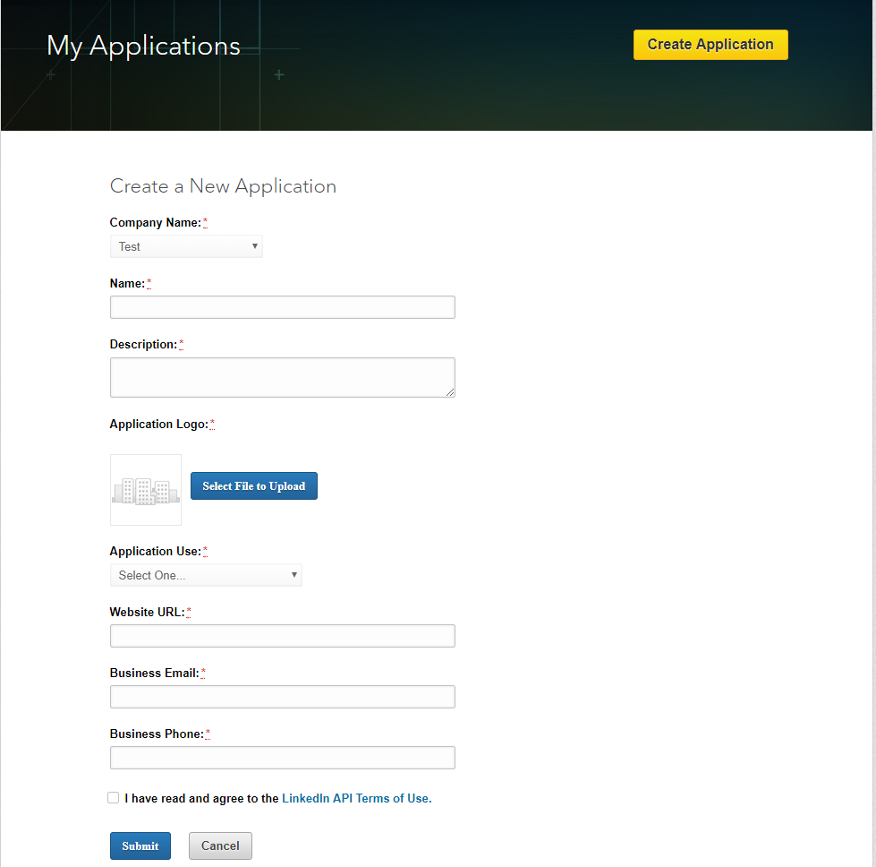

We need provide the valid URLs that you have identified as trusted endpoints. Also, we can grant the Application Permission

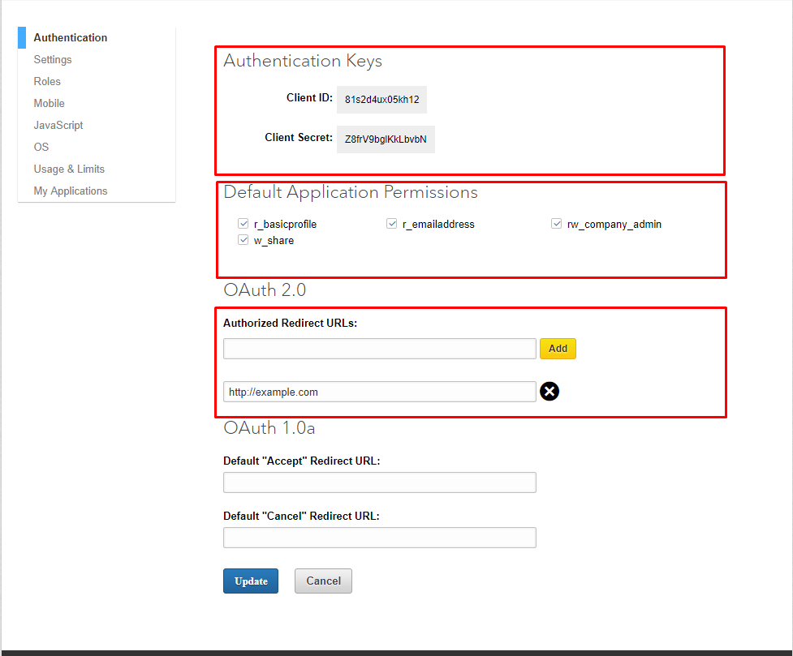

We will make the request to get the authorization code, below:

https://www.linkedin.com/oauth/v2/authorization?response_type=code&client_id={1}&redirect_uri={2}&state={3}&scope={4}

{1}: Client Id

{2}: Authorized Redirect URL which we configured

{3}: A unique string value of your choice that is hard to guess. e.g. state=DCEeFWf45A53sdfKef424

{4}: Application Permission. Space delimited list of member permissions your application is requesting on behalf of the user. e.g. scope=r_basicprofile%20r_emailaddress%20w_share

After we made that request, we need to provide the permission

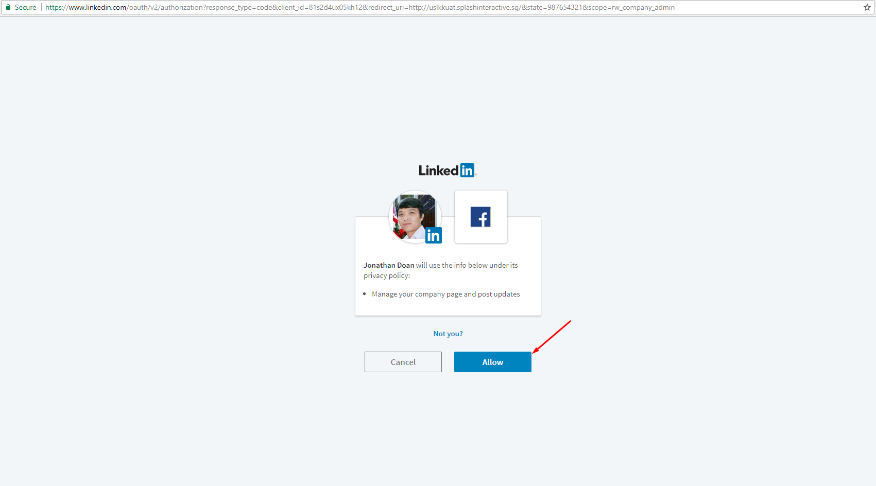

You will be redirect to URL that you added before



Copy the code in red rectangle above and make a request to get the access token

https://www.linkedin.com/oauth/v2/accessToken?grant_type=authorization_code&code={1}&redirect_uri={2}&client_id={3}&client_secret={4}

{1}: The code you copied

{2}: Authorized Redirect URL we configured

{3}: Client Id

{4}: Client Secret

The result:



Note: Please provide the **Access Token** and **Company Id**

About the Company Id, please access to your account on Linkedin

1. Click the Me icon at the top of your LinkedIn homepage.
2. Below Manage, select your Company Page.

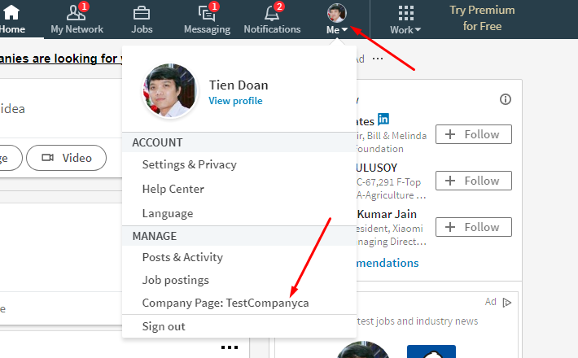

From the URL on the browser, copy the number like as:

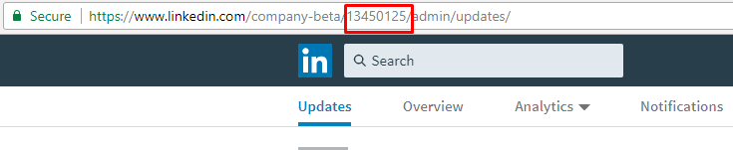

# Instagram

Access to the <https://www.instagram.com/developer> and click on the menu “Manage Clients” to create a client. You need to login to do this.

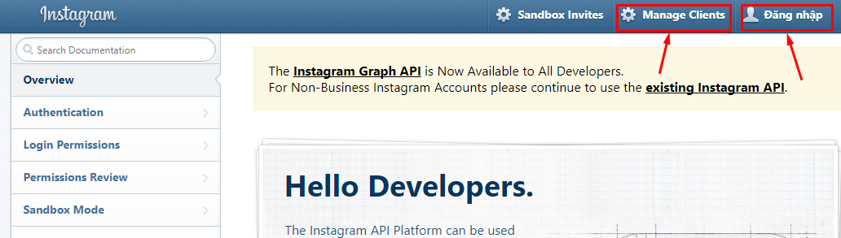

Click on the “Register a New Client” and fulfill the information

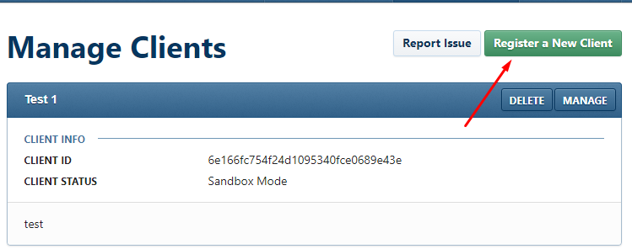

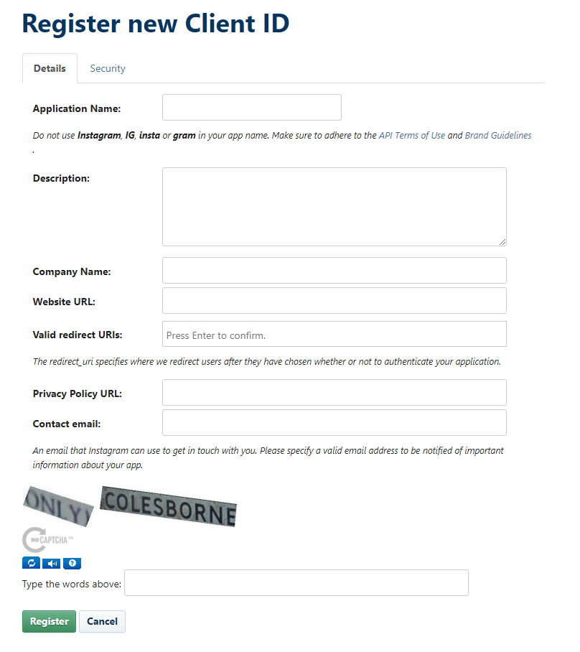

Then click on “Register” button

After that we will see the new client which has just created.

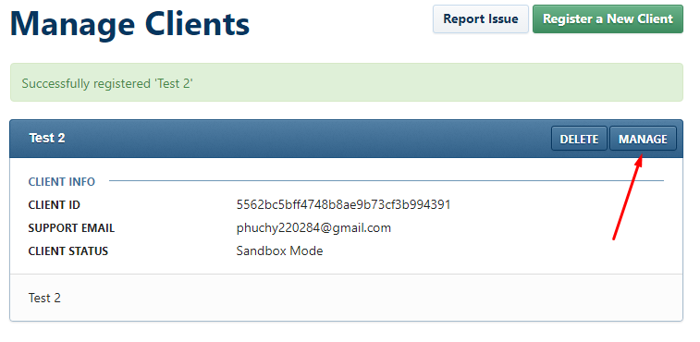

Click on the “MANAGE” button to navigate to client’s details

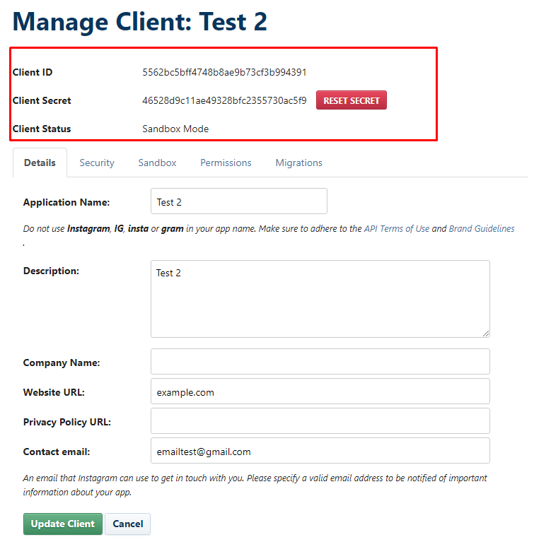

We will make a request to get the authorization code, below:

[https://api.instagram.com/oauth/authorize/?client_id={1}&redirect_uri={2}&response_type=code&scope={3}](https://api.instagram.com/oauth/authorize/?client_id=%7b1%7d&redirect_uri=%7b2%7d&response_type=code&scope=%7b3%7d)

{1}: Client ID

{2}: The Valid Redirect URI, below

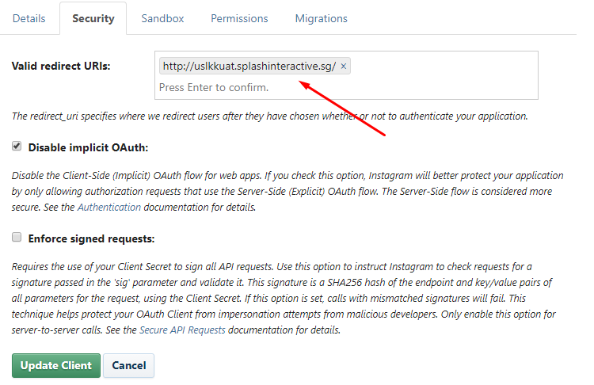

{3}: You may provide an optional **scope** parameter to request additional permissions outside of the “basic” permissions scope:

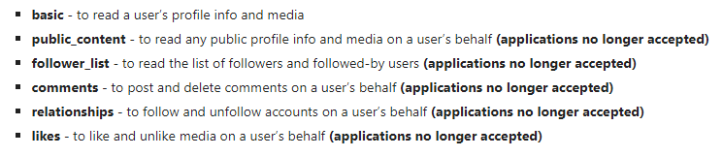

To request multiple scopes at once, simply separate the scopes by a space. In the url, this equates to an escaped space (“+”). So if you are requesting the likes and comments permission, the parameter will look like this:

scope=likes+comments

Click on the “Authorize” button to grant the permission

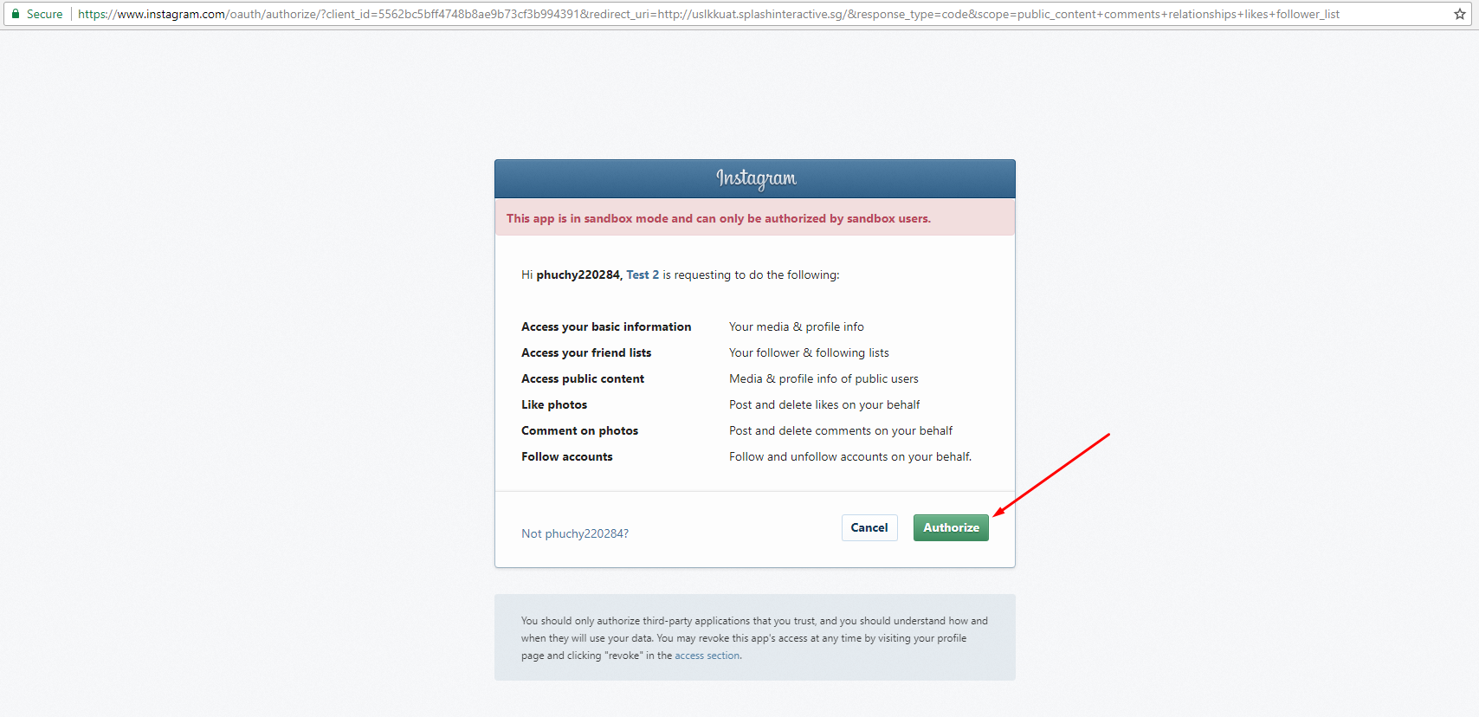

We will be redirected to the URL you configured before. Then we will copy the authorization code:



Use Postman to make a request to get the access token. You can find the Postman for Chrome browser here: <https://chrome.google.com/webstore/detail/postman/fhbjgbiflinjbdggehcddcbncdddomop?hl=en>

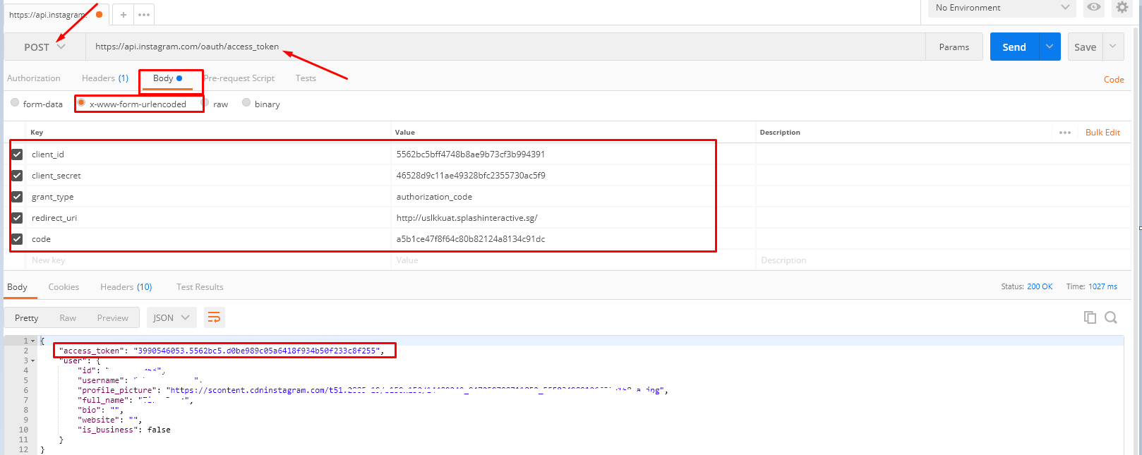

Note: Please provide the **Access Token**